

University of Cape Town

EEE3097S

Engineering Principles: Electrical And Computer Engineering

**First Progress Report**

*Authors: Student Numbers:*

David Young YNGDAV005

Caide Spriestersbach SPRCAI002

September 2022

Table of Contents

Table of Figures - 1 -

List of Tables - 1 -

Administrative Details - 2 -

Individual Contributions - 2 -

Project Management Tool - 2 -

Development Timeline - 2 -

GitHub Link - 3 -

1. Data - 4 -

1.1. Data Used - 4 -

1.2. Justification of Data Used - 4 -

1.3. Initial Analysis of Data - 4 -

2. Experiment Setup - 8 -

2.1. Experiments to Check Overall Functionality of the System - 8 -

2.2. Experiments for Compression Block - 8 -

2.3. Experiments for Encryption Block - 8 -

2.4. Expected Data to be Retrieved and Returned From Each Block - 9 -

3. Results - 9 -

3.1. Results of Experiments to Check Overall Functionality of the System - 9 -

3.2. Results of Experiments for Compressions Block - 10 -

3.3. Results of Experiments for Encryption Block - 11 -

3.4. Effects of Changing the Data Provided to the System - 12 -

4. Simulated Data Acceptance Test Procedures - 13 -

4.1. Compression ATPs - 13 -

4.2. Encryption ATPs - 14 -

4.3. Checksum ATPs - 14 -

References - 15 -

# Table of Figures

Figure 1 – Screenshot of project management tool front page - 2 -

Figure 2 – Development timeline for the project - 2 -

Figure 3 – Graph of time in seconds vs temperature readings - 5 -

[Figure 4 - Graph of time vs magnitude of acceleration - 5 -](https://uctcloud-my.sharepoint.com/personal/yngdav005_myuct_ac_za/Documents/EEE3097S_2022_PR_1_GROUP_20_YNGDAV005_SPRCAI002.docx#_Toc113899936)

Figure 5 – Graph of time vs magnitude of gyroscope measurements - 6 -

[Figure 6 – Graph displaying the Fourier Transform of the Temperature data - 6 -](https://uctcloud-my.sharepoint.com/personal/yngdav005_myuct_ac_za/Documents/EEE3097S_2022_PR_1_GROUP_20_YNGDAV005_SPRCAI002.docx#_Toc113899938)

[Figure 8 – Graph depicting the Fourier Transform of the gyroscope data - 7 -](https://uctcloud-my.sharepoint.com/personal/yngdav005_myuct_ac_za/Documents/EEE3097S_2022_PR_1_GROUP_20_YNGDAV005_SPRCAI002.docx#_Toc113899939)

[Figure 7 – Graph showing the Fourier Transform of the acceleration data - 7 -](https://uctcloud-my.sharepoint.com/personal/yngdav005_myuct_ac_za/Documents/EEE3097S_2022_PR_1_GROUP_20_YNGDAV005_SPRCAI002.docx#_Toc113899940)

Figure 9 – Command-line output from the overall functionality experiment - 9 -

Figure 10 – Decryption using the correct password - 11 -

Figure 11 – Decryption using an incorrect password - 12 -

Figure 12 - Command-line output from the overall functionality experiment with noise - 12 -

# List of Tables

Table I – Table of individual contributions made by each member - 2 -

Table II – Raw results for the compression block experiments - 10 -

Table III – Calculated results for the compression block experiments - 10 -

Table IV – Raw results for the encryption block experiments - 11 -

Table V – Calculated results for the encryption block experiments - 11 -

Table VI – Changes due to adding noise to the data set - 13 -

Table VII – Simulation Data ATPs for the compression block - 13 -

Table VIII – Simulated Data ATPs for the encryption block - 14 -

Table IX – Simulated Data ATPs for the checksum block - 14 -

# Administrative Details

## Individual Contributions

Both members worked equally on the project and contributed to each section. However, some areas were focused more heavily on by a specific member. These sections are listed below.

|  |  |  |
| --- | --- | --- |
| Name | Sections | Pages |
| David Young  YNGDAV005 | 2.1, 2.2, 2.4, 3.1, 3.2, 3.4, 4.1, 4.3 | 8-10, 12-14 |
| Caide Spriestersbach  SPRCAI002 | 1.1, 1.2, 1.3, 2.3, 3.3, 4.2 | 1-7, 8-9, 11-12, 14 |

Table – Table of individual contributions made by each member

## Project Management Tool

Below is a screenshot of the front page of our project management tool as of Tuesday, 6th September 2022.



Figure – Screenshot of project management tool front page

## Development Timeline

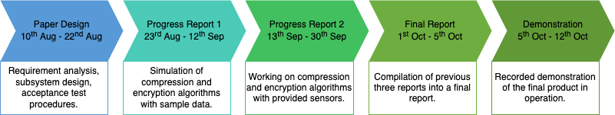

Figure – Development timeline for the project

## GitHub Link

The members made use of a GitHub git repository used throughout this project. Below is a link to the GitHub repository.

<https://github.com/the-user-created/EEE3097S-Project>

# 1. Data

Supplying the algorithms used for compression and encryption with simulated data was done to validate the workings of these algorithms. The following information concerns the data sets used, the file formats and how this relates to the compression and encryption for the SHARK Buoy project.

## 1.1. Data Used

The members decided to use simulated data as it would replicate the type of information we would receive from the Sense Hat B on the buoy in Antarctica. The file formats used in testing were binary, text and Comma-Separated Values (CSV), as it is common in Digital Signal Processing to use these file formats. Hence, it is essential to test the encryption and compression of these file types. Encryption and compression occurred on different data sets (in three file formats). The first data set was collected by the user carrying the Inertial Measurement Unit (IMU) in their pocket and the user walking around, sitting down and standing for over 5 minutes. The second data set recordings were from the IMU being fixed on a rotation program – the IMU was appointed to one of its axes, and the data were recorded for 10 minutes. The third data set was the same recording environment as the second, however, at a lower sample rate.

## 1.2. Justification of Data Used

The simulated data will accurately represent the data recorded on the buoy in Antarctica; therefore, the data sets will be suitable for testing the compression and encryption blocks. Different file sizes and types were tested to test the efficiency of the encryption and compression algorithm and ensure functionality. The file format in which the data will be stored and processed from the Sense Hat and IMU has not been finalised. The file format to be used will be completed once testing with the IMU and Sense Hat commences. It was then decided to test multiple file formats in the simulation phase to ensure that the encryption and compression would work with the file format used in the final product. The simulated data will be compared against the experimental data to test the acceptance test procedures and receive figures of merit. Following compression, encryption, decryption and decompression, the file will be in the same format as the IMU recorded; this can only be achieved in the simulation if the data set and format are the same as the one used in the practical application.

## 1.3. Initial Analysis of Data

Since the files contain similar data sets, it was decided to use the first thousand samples from the "EEE3097S 2022 Turntable Example Data 2.csv". The following three plots depict the relationship of the data collected from the IMU in the time domain; the following three plots show a sample of the Fourier Transform. Since the compression and encryption algorithms are both lossless, 25% of the Fourier Coefficients will be preserved – satisfying the user requirement. The project focuses on the encryption and compression of the files which contain the data; it was therefore not considered of high importance to value the IMU will determine the data set as this on the buoy – the following is, therefore, an example of how the data can be graphed for analysis.

Time (s)

Temperature (°C)

Figure – Graph of time in seconds vs temperature readings

Figure - Graph of time vs magnitude of acceleration

Time (s)

Acceleration

Time (s)

Gyroscope Magnitude

Figure – Graph of time vs magnitude of gyroscope measurements

The following three graphs depict the Fourier transform of the simulated data. These graphs show what the data sets should produce once they have been decrypted, decompressed and analysed

what the data sets should make once they have been decrypted, decompressed and analysed using software such as Matlab. Matlab_R2022a was used to produce the following graphs.

Figure – Graph displaying the Fourier Transform of the Temperature data

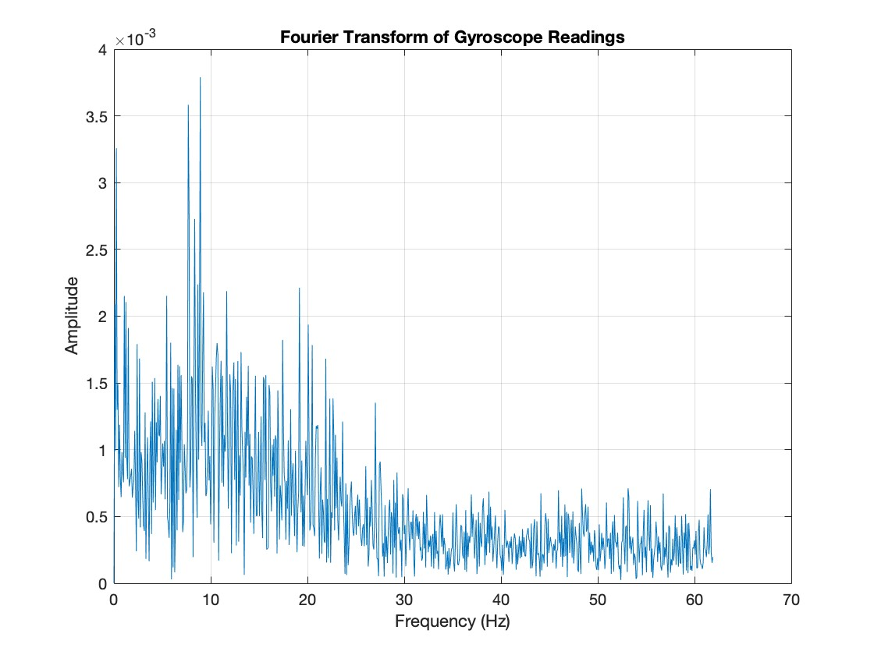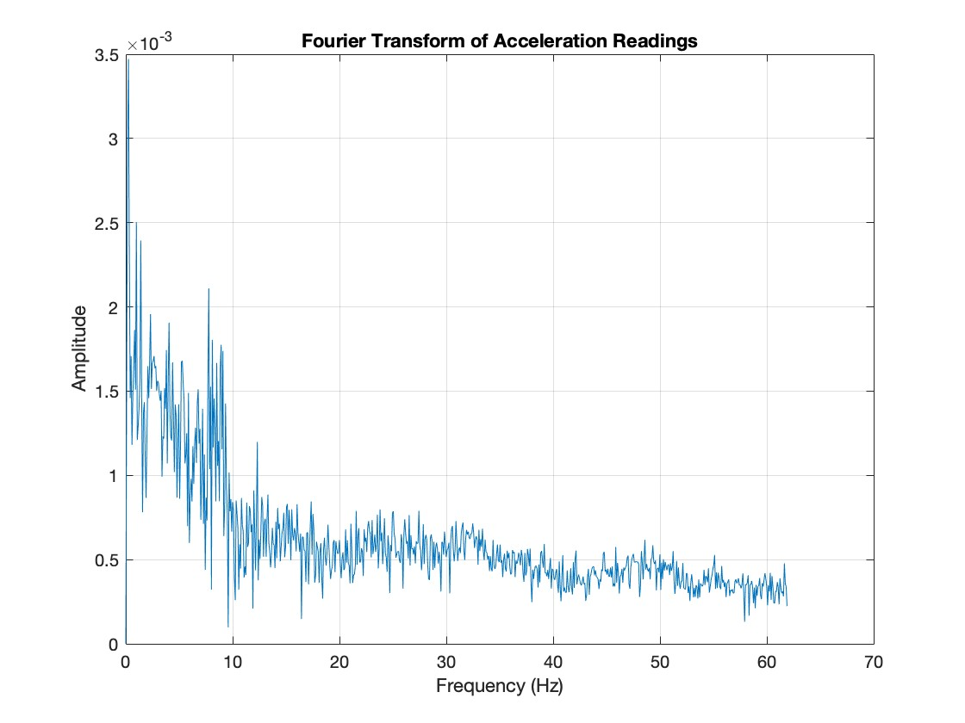As seen above, significant noise is present in the graphs except for temperature – which has a spike at the origin, whereas the others follow an unexpected relationship.

Figure – Graph depicting the Fourier Transform of the gyroscope data

Figure – Graph showing the Fourier Transform of the acceleration data

# 2. Experiment Setup

## 2.1. Experiments to Check Overall Functionality of the System

The overall System uses a combination of encryption and compression functions in one Python file. The compression block will compress the input data file, passing the output file to the encryption block to encrypt the compressed file. The encrypted file can then be decrypted and decompressed to retrieve the original data. After decryption and decompression, a Python built-in comparison function is then used to make a deep comparison between the original data file and the resultant data file. Since both the compression and encryption algorithms are lossless, the input and output files should be identical.

## 2.2. Experiments for Compression Block

The compression block was tested across various use cases to determine values that could be used as comparisons for respective ATPs determined in the paper design. All the tests were executed across the same three sets of sample data:

* "EEE3097S_2022_Turntable_Example_Data_2.csv"
* "EEE3097S_2022_Turntable_Example_Data.csv"
* "EEE3097S_2022_Walking_Around_Example_Data.csv"

While the tests have peripheral objectives related to the ATPs, the main aim of the compression block is to reduce the physical space required to store the data whilst retaining all data inside the file. The Lempel–Ziv–Markov chain algorithm (LZMA) was used for compression. The original file size is compared to the compressed file size for each sample data set to determine the compression ratio. The execution time of the compression and decompression for each sample data set can also be determined using the Python time library. Lastly, the input and output files are compared for each sample data set to determine if the compression and decompression are lossless.

## 2.3. Experiments for Encryption Block

Testing the encryption block consisted of various stages. Testing was done in phases to obtain values which could then be used for comparisons and verify the respective ATPs. All the tests were done on the sample data provided by the compression algorithm:

* "EEE3097S_2022_Turntable_Example_Data_2.csv.lz"
* "EEE3097S_2022_Turntable_Example_Data.csv.lz"
* "EEE3097S_2022_Walking_Around_Example_Data.csv.lz".

While the tests have peripheral objectives related to the ATPs, the primary function of the encryption block is to convert plaintext data into ciphertext, which cannot trivially be decrypted without the password. The encryption algorithm used was the Twofish algorithm developed by Bruce Schneier. The original file was compared to the encrypted file for each file to determine whether the encryption was successful. The execution time for encryption and decryption of each data file was determined using the built-in Python time library. Determining if the encryption was lossless was done by comparing the files provided to the algorithm (the compressed files) and the files following decryption.

## 2.4. Expected Data to be Retrieved and Returned From Each Block

The compression block is expected to retrieve IMU data as a CSV file. The compression block will read the CSV file and output the compressed .lz file. The encryption block will then retrieve this .lz file and encrypts it into a .lz.tf file. The decryption algorithm will then retrieve the .lz.tf file and decrypt it into a .lz file. This .lz file is retrieved by the decompression algorithm, which will output a CSV file.

# 3. Results

## 3.1. Results of Experiments to Check Overall Functionality of the System

The output for the overall functionality experiment is shown below:

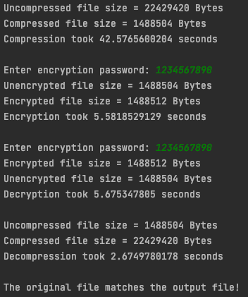

Figure – Command-line output from the overall functionality experiment

The sample data set used for this experiment was "EEE3097S_2022_Turntable_Example_Data.csv". The uncompressed file has a size of 22429420 bytes and a compressed size of 1488504 bytes – this which means that a compression ratio of 15.1 was achieved. The compression took 42.58 seconds, and the decompression took 2.67 seconds. The encryption took 5.58 seconds, and the decryption took 5.68 seconds. The encryption added 8 bytes to the compressed file because the compressed file was not a multiple of 16 bytes (block size). These 8 bytes acted as padding for the encryption algorithm so that the file's content was correctly encrypted. The last line output in the figure above shows that the original file is identical to the decompressed file; therefore, the compression and encryption are both lossless.

## 3.2. Results of Experiments for Compressions Block

The output for the compression experiment is shown below in table form:

|  |  |  |  |  |
| --- | --- | --- | --- | --- |
| File | Original File Size [bytes] | Compressed File Size [bytes] | Compression Time [seconds] | Decompression Time [seconds] |
| Turntable_1 | 22 429 420 | 1 488 504 | 41.6754570007 | 2.6192178726 |
| Turntable_2 | 19 827 842 | 939 264 | 30.4814031124 | 1.7084400654 |
| Walking | 14 332 601 | 1 353 856 | 29.0786149502 | 2.7873430252 |

Table – Raw results for the compression block experiments

The values in the table below were calculated from those in the table above.

|  |  |  |  |
| --- | --- | --- | --- |
| File | Compression Ratio | Compression Speed [bytes/second] | Decompression Speed [bytes/second] |
| Turntable_1 | 15.06843112 | 538 192.5385 | 8 563 403.692 |
| Turntable_2 | 21.1099776 | 650 489.8061 | 11 605 816.56 |
| Walking | 10.58650329 | 492 891.4608 | 5 142 029.836 |
|  |  |  |  |
| Average | 15.588304 | 560 624.6018 | 8 437 083.363 |

Table – Calculated results for the compression block experiments

As can be seen from the results shown in the table above, LZMA appears to be a high-speed and efficient compression algorithm.

## 3.3. Results of Experiments for Encryption Block

The output for the encryption experiment is shown below in table form:

|  |  |  |  |  |
| --- | --- | --- | --- | --- |
| Compressed File | Original File Size [bytes] | Encrypted File Size [bytes] | Encryption Time [seconds] | Decryption Time [seconds] |
| Turntable_1.lz | 1 488 504 | 1 488 512 | 5.5718431473 | 5.5043358803 |
| Turntable_2.lz | 939 264 | 939 264 | 2.2277162075 | 2.3133990765 |
| Walking.lz | 1 353 856 | 1 353 856 | 4.4565820694 | 4.6864788532 |

Table – Raw results for the encryption block experiments

The values in the table below were calculated from those in the table above.

|  |  |  |  |
| --- | --- | --- | --- |
| File | Used Padding | Encryption Speed [bytes/second] | Decryption Speed [bytes/second] |
| Turntable_1 | Yes | 267 147.5059 | 270 425.3578 |
| Turntable_2 | No | 421 626.4158 | 406 010.3635 |
| Walking | No | 303 787.9655 | 288 885.5455 |
|  |  |  |  |
| Average | - | 330 853.9624 | 321 773.7556 |

Table – Calculated results for the encryption block experiments

As seen by the data, we can conclude that Twofish is slightly faster at encrypting files than decrypting files. It is still, however, a high-speed and efficient algorithm.

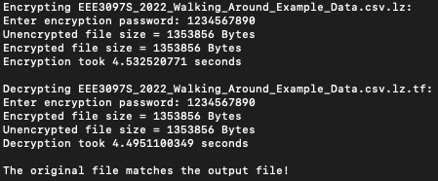

Figure – Decryption using the correct password

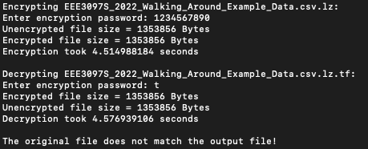

Figure – Decryption using an incorrect password

As can be seen by comparing Figure 10 and Figure 11, the decryption fails when an incorrect password is provided to the decryption algorithm.

## 3.4. Effects of Changing the Data Provided to the System

Noise was added to the data points in the "EEE3097S_2022_Turntable_Example_Data.csv" to determine whether such a change in the data will affect the compression performance or encryption performance. As seen in the figure below, the performance of both the compression and encryption has been severely affected compared to the result shown in Figure 9, which used the original data set.

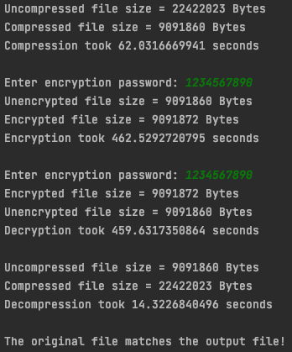

Figure - Command-line output from the overall functionality experiment with noise

A table presenting the difference in the results between those in section 3.1 and this experiment is shown below:

|  |  |  |  |  |
| --- | --- | --- | --- | --- |
|  | Change in Input File Size [bytes] | Change in Output File Size [bytes] | Change in Speed [bytes/second] | Change in Speed (with original data set as baseline) [Percentage] |
| Compression | 4397 | 7 603 356 | 165 342.3952 | -31.4% |
| Decompression | 7 603 356 | 4397 | 6 819 408.507 | -81.3% |
| Encryption | 7 603 356 | 7 603 360 | 247 011.6069 | -92.6% |
| Decryption | 7 603 360 | 7 603 356 | 242 496.0141 | -92.5% |

Table – Changes due to adding noise to the data set

As can be seen, by the severe changes in performance, adding noise to the data set will harm the performance of both compression and encryption.

# 4. Simulated Data Acceptance Test Procedures

## 4.1. Compression ATPs

|  |  |  |  |
| --- | --- | --- | --- |
| ATP | Description | ATP achieved | Comment |
| Compression time | The compression algorithm must not take more than 5 seconds per 10 kilobytes of data. | Yes | Table III shows that the compression algorithm achieved an average speed of ~560 000 bytes per second, which is far more than 2048 bytes per second. |
| Data loss | No data must be lost during the compression of the data file. | Yes | LZMA uses lossless compression, validated by the deep file comparison in section 3.1. |
| Compression effectiveness | The compression ratio of the original file size and the compressed file size must be at least 1.5. | Yes | Table III shows that the compression algorithm achieved an average compression ratio of ~15.6, which is far more significant than 1.5. |

Table – Simulation Data ATPs for the compression block

## 4.2. Encryption ATPs

|  |  |  |  |
| --- | --- | --- | --- |
| ATP | Description | ATP achieved | Comment |
| Encryption time | The encryption and decryption execution time should not exceed 10 seconds per 10 kilobytes of data. | Yes | Table V shows that the encryption algorithm achieved an average speed of ~330 000 bytes per second, surpassing the ATP. |
| Data loss | No data must be lost during the encryption and decryption of the data file. | Yes | As shown in section 3.1, the compression and encryption are both lossless. |
| Encryption security | The encryption must be strong enough to prevent decryption. | Yes | This ATP is difficult to test, but the encryption prevents trivial decryption attempts, as shown in section 3.3, figures 10 and 11. |
| Encryption integrity | The original data in the file must be identical to the decrypted data in the output file. | Yes | As shown in section 3.1, the compression and encryption are both lossless. |

Table – Simulated Data ATPs for the encryption block

## 4.3. Checksum ATPs

|  |  |  |  |
| --- | --- | --- | --- |
| ATP | Description | ATP achieved | Comment |
| STM checksum | The STM must create a checksum of the original data file successfully. | No | No data collection from the STM could be created; therefore, no checksum. |
| Client checksum | The client's device must successfully create a checksum of the decrypted and decompressed file. | Yes | The checksum for the client was created using Python successfully. |
| Checksum comparison | The client's and STM's checksums must be identical. | No | Unable to create checksum on STM. |

Table – Simulated Data ATPs for the checksum block

# References

**There are no sources in the current document.**